HM5C-DeepPred

HM5C-Deep: A Deep Learning Model based Server to predict hm5c and non-hm5c sites.

HM5C-Deep server is based on the Deep Convolutional Neural Network (CNN) Model developed to predict hm5c and non-hm5c sites on providing RNA sequence(s). This proposed prediction model identify the hm5c sites with increased accuracy.

HM5C-DeepPred (online Predictor)

ON The basis of this proposed model a web based application has also been developed, which can be used for the identification of 5hmC sites by providing an RNA sequence. One can use Predict page for the prediction of hm5c or extract the same features used in this study from the site by moving on the link Encode page. The link to the running model is https://hm5c-deeppred.streamlit.app. A complete help to use the online server is provided at the bottom of the page after the wrokflow diagram.

HM5C-Deep Workflow diagram
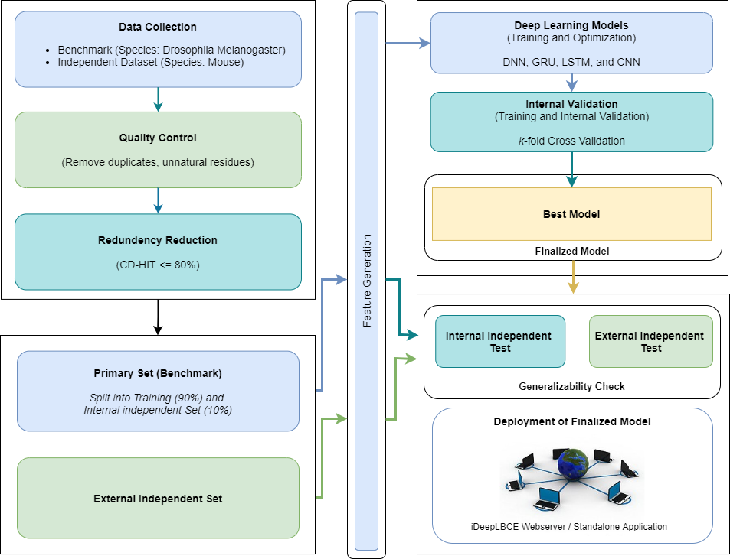

Help to use the online predictor

Step 1: The free streamlit based web app sleeps after two days of no traffic. If so, click the blue button titled as "Yes, get this app back up!"

Step 2: Choose the Predict Page from the given menu to make predictions
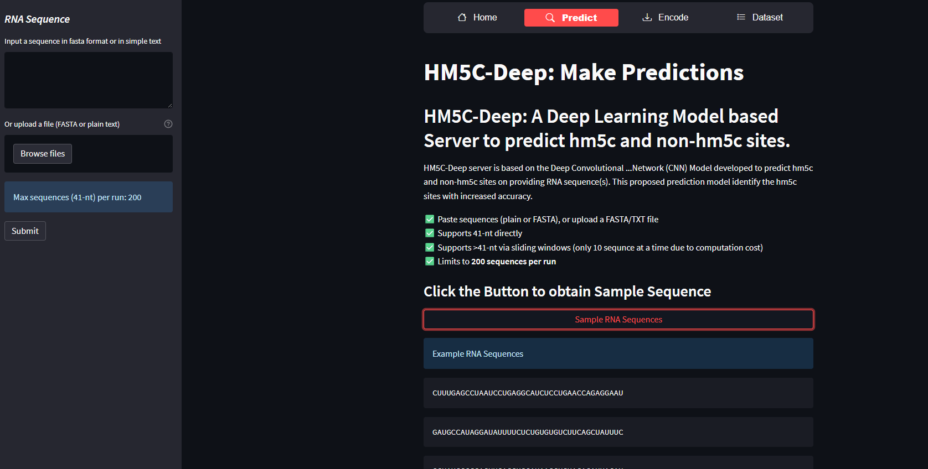

Step 3: Paste any RNA sequence in the Input Area or upload a file and then press Submit
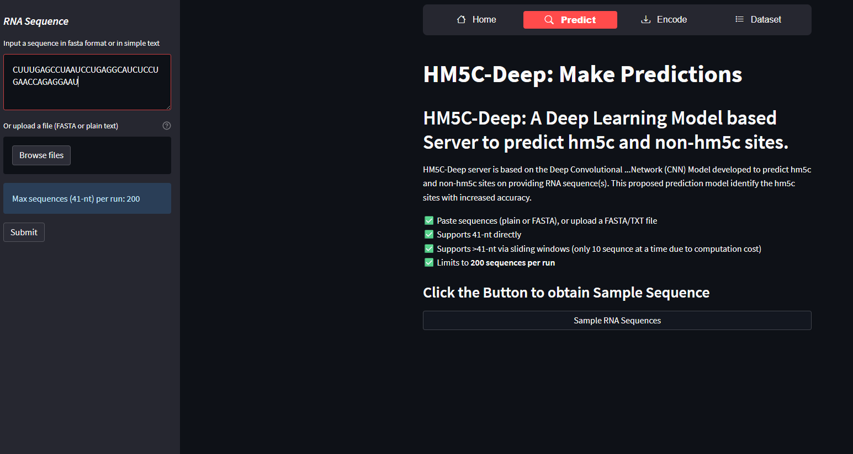

Step 4: Results will appear on the page, even you can download results in csv format
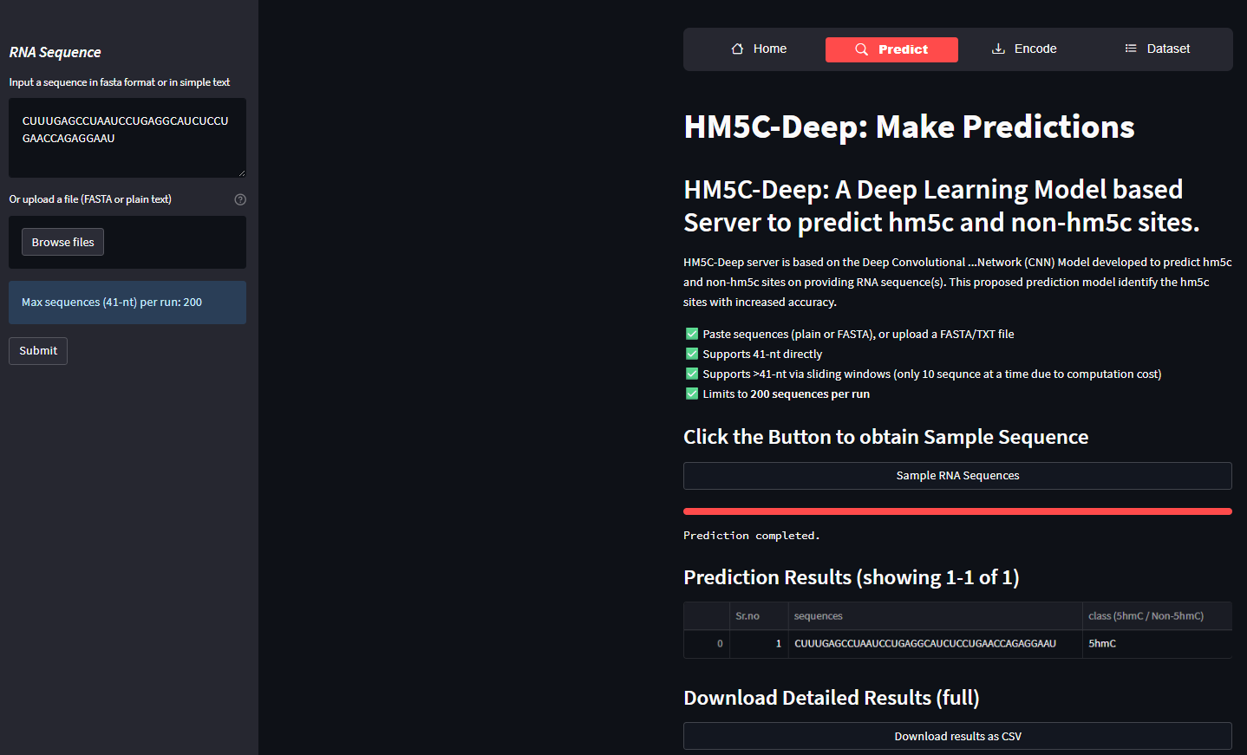

You can encode features by putting the sequences at Encode Page view and download features in csv format
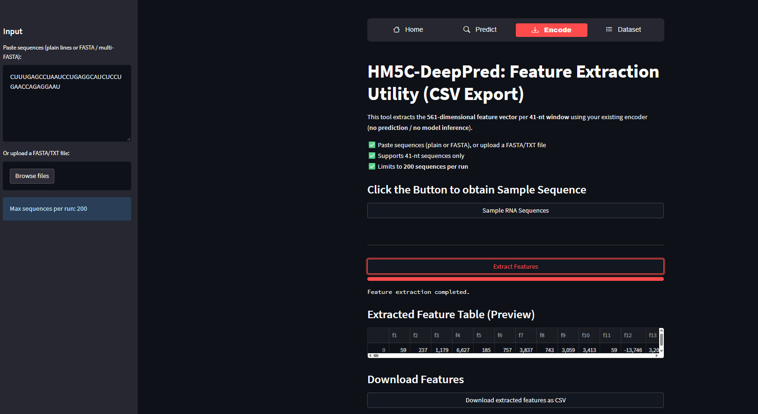

Benchmark Dataset is also available at Dataset page
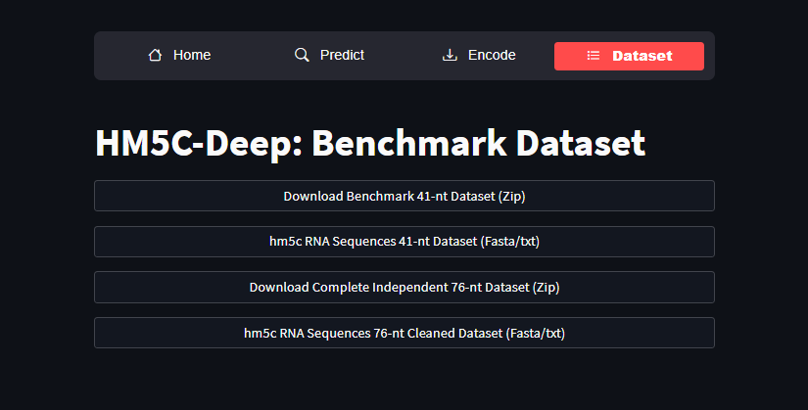

Python version and libraries used in this study

python==3.10.18

requirements.txt

tensorflow==2.10.0

keras==2.10.0

numpy==1.23.4

pandas==1.5.1

scikit_learn==1.1.3

streamlit==1.20.0

